**MOVIE RATINGS ANALYSIS ON APACHE SPARK**

Please find the below detailed steps done/analysis on Movie Rating :

1. Downloaded the Data Files from the MovieLens Site.

Here’s the URL : <https://grouplens.org/datasets/movielens/>

1. Transferring the Data Files in aws – ec2 machine using FTP or AWS-EC2 Machine.
2. Putting the Data in the HDFS – Hadoop File System
3. Analysis the data on Spark running on HDFS ,
4. Creating and Loading of Data into Spark RDD
5. Conversion of Spark RDD into Data Frames
6. Usage of CreateorReplaceTempView and using spark.sql on the same.
7. Carrying the analysis of the structured data once converted to DF

hadoop fs -ls /user/edureka_918210/MovieLens

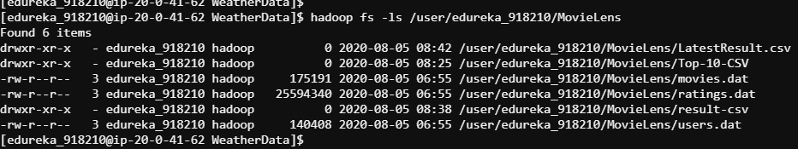

**Prepare_Ratings**

val ratingsRDD=spark.sparkContext.textFile("/user/edureka_918210/MovieLens/ratings.dat")

import org.apache.spark.sql.Row;

import org.apache.spark.sql.types.{StructType, StructField, StringType};

val schemaString = "UserID MovieID Rating Timestamp"

val schema = StructType(schemaString.split(" ").map(fieldName => StructField(fieldName, StringType, true)))

val rowRDD = ratingsRDD.map(_.split("::")).map(x => Row(x(0), x(1), x(2), x(3)))

val ratings = spark.createDataFrame(rowRDD, schema)

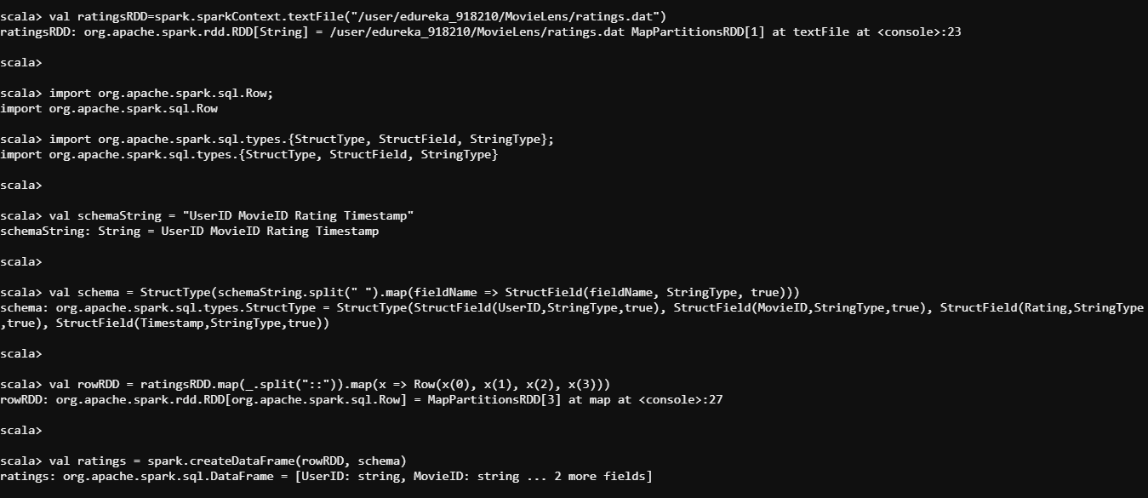

ratings.printSchema

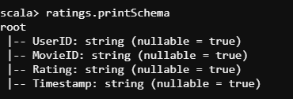

**Prepare_Users**

val usersRDD=spark.sparkContext.textFile("/user/edureka_918210/MovieLens/users.dat")

import org.apache.spark.sql.Row;

import org.apache.spark.sql.types.{StructType, StructField, StringType};

val schemaString = "UserID Gender Age Occupation Zip-code"

val schema = StructType(schemaString.split(" ").map(fieldName => StructField(fieldName, StringType, true)))

val rowRDD = usersRDD.map(_.split("::")).map(x => Row(x(0), x(1), x(2), x(3), x(4)))

val users_1 = spark.createDataFrame(rowRDD, schema)

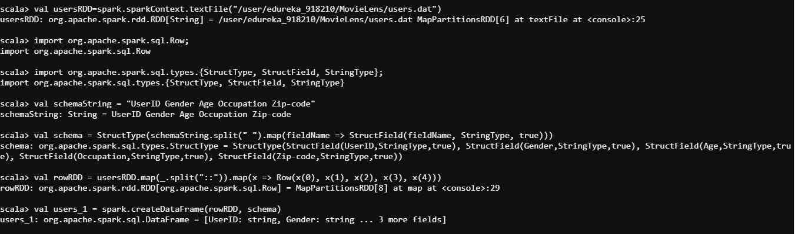

users_1.printSchema

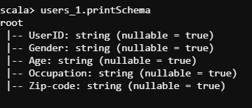

**Prepare_Ratings**

val ratingsRDD=spark.sparkContext.textFile("/user/edureka_918210/MovieLens/ratings.dat")

import org.apache.spark.sql.Row;

import org.apache.spark.sql.types.{StructType, StructField, StringType};

val schemaString = "UserID MovieID Rating Timestamp"

val schema = StructType(schemaString.split(" ").map(fieldName => StructField(fieldName, StringType, true)))

val rowRDD = ratingsRDD.map(_.split("::")).map(x => Row(x(0), x(1), x(2), x(3)))

val ratings = spark.createDataFrame(rowRDD, schema)

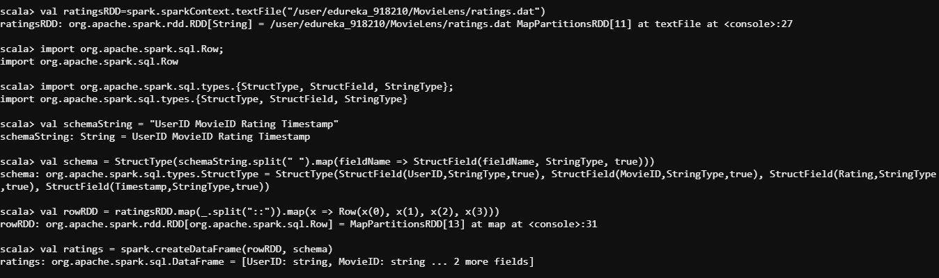

ratings.printSchema

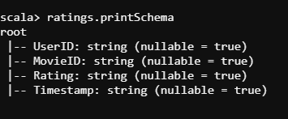

**Prepare_Movies**

// Clean data into DataFrame

val movies=spark.read.textFile("/user/edureka_918210/MovieLens/movies.dat")

val m_id=movies.map(lines=>lines.split("::")(0)).toDF("MovieID")

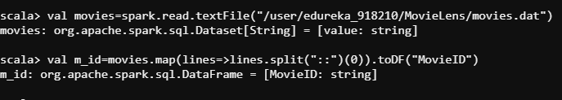

//Extract the title

val title=movies.map(lines=>lines.split("::")(1))

val m_title=title.map(x=>x.split("\\(")(0)).toDF("Title")

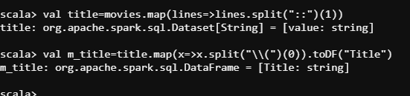

//Extract the year

val year=movies.map(lines=>lines.substring(lines.lastIndexOf("(")+1,lines.lastIndexOf(")"))).toDF("Year")

val m_genre=movies.map(lines=>lines.split("::")(2)).toDF("Genres")

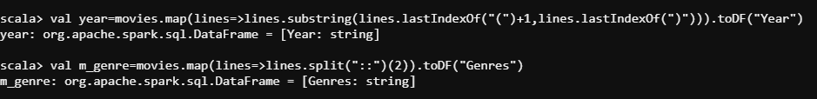

// For appending the dataframes, we need to import monotonically_increasing_id

import org.apache.spark.sql.functions.monotonically_increasing_id

val m_res1=m_id.withColumn("id", monotonically_increasing_id()).join(m_title.withColumn("id", monotonically_increasing_id()), Seq("id")).drop("id")

val m_res2=m_res1.withColumn("id", monotonically_increasing_id()).join(year.withColumn("id",monotonically_increasing_id()),Seq("id")).drop("id")

val m_result=m_res2.withColumn("id", monotonically_increasing_id()).join(m_genre.withColumn("id", monotonically_increasing_id()), Seq("id")).drop("id")

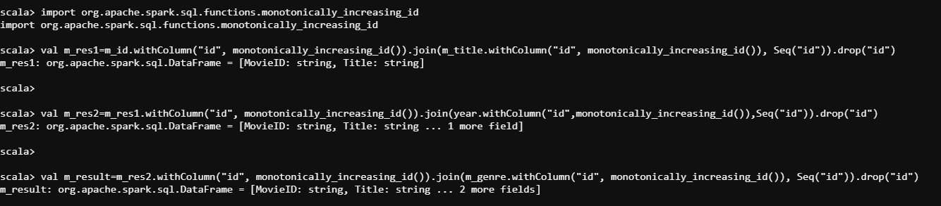

// This will give us the valid data with schema

m_result.show

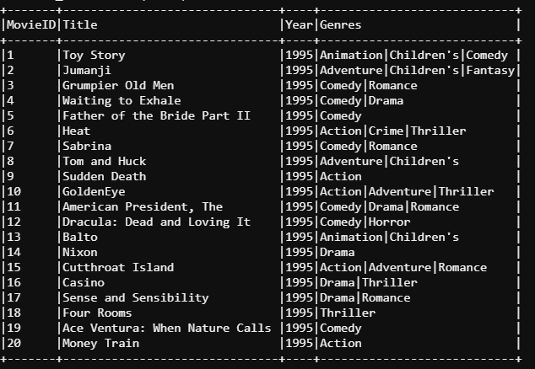

**SOME OF THE IMPORTANT EXAMPLES :**

m_result.where("MovieID=1").show(false)

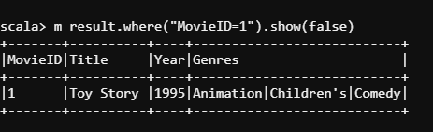

m_result.filter("Genres == 'Action'").show(false)

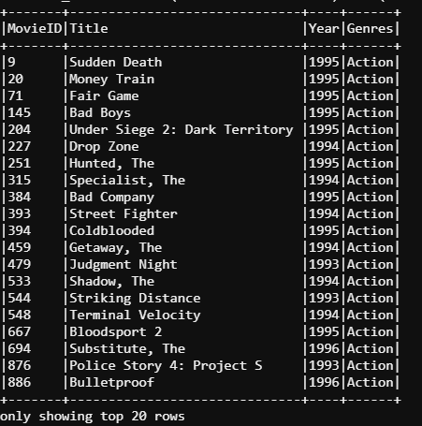

m_result.select("Title").show(false)

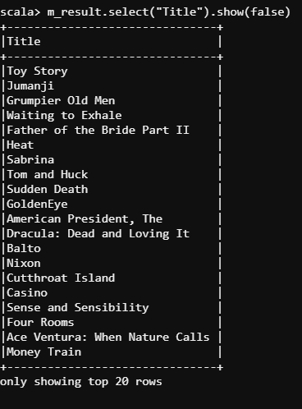

m_result.filter("Year == '1995'").show(false)

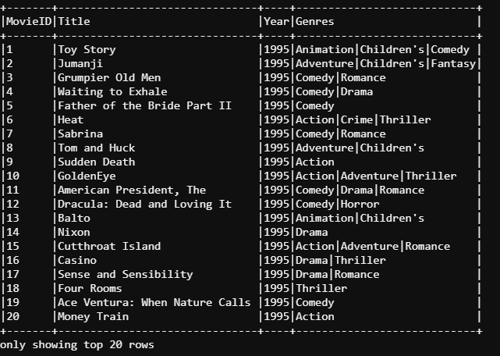

**TOP 10 Viewed Movies**

val ratingsRDD=sc.textFile("/user/edureka_918210/MovieLens/ratings.dat")

val movies=ratingsRDD.map(line=>line.split("::")(1).toInt)

val movies_pair=movies.map(mv=>(mv,1))

val movies_count=movies_pair.reduceByKey((x,y)=>x+y)

val movies_sorted=movies_count.sortBy(x=>x._2,false,1)

val mv_top10List=movies_sorted.take(10).toList

val mv_top10RDD=sc.parallelize(mv_top10List)

val mv_names=sc.textFile("/user/edureka_918210/MovieLens/movies.dat").map(line=>(line.split("::")(0).toInt,line.split("::")(1)))

val join_out=mv_names.join(mv_top10RDD)

join_out.sortBy(x=>x._2._2,false).map(x=> x._1+","+x._2._1+","+x._2._2).repartition(1).saveAsTextFile("/user/edureka_918210/MovieLens/Top10-CSV")



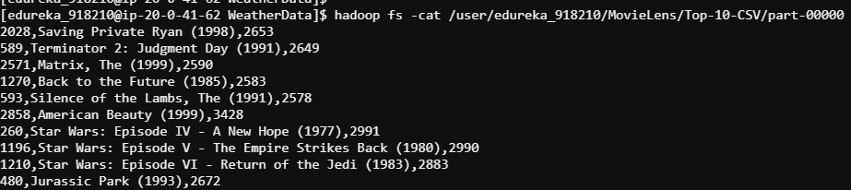

**Movies In Each Genre**

val movies_rdd=sc.textFile("/user/edureka_918210/MovieLens/movies.dat")

val genre=movies_rdd.map(lines=>lines.split("::")(2))

val flat_genre=genre.flatMap(lines=>lines.split("\\|"))

val genre_kv=flat_genre.map(k=>(k,1))

val genre_count=genre_kv.reduceByKey((k,v)=>(k+v))

val genre_sort= genre_count.sortByKey()

genre_sort.saveAsTextFile("/user/edureka_918210/MovieLens/resultgenre-csv")

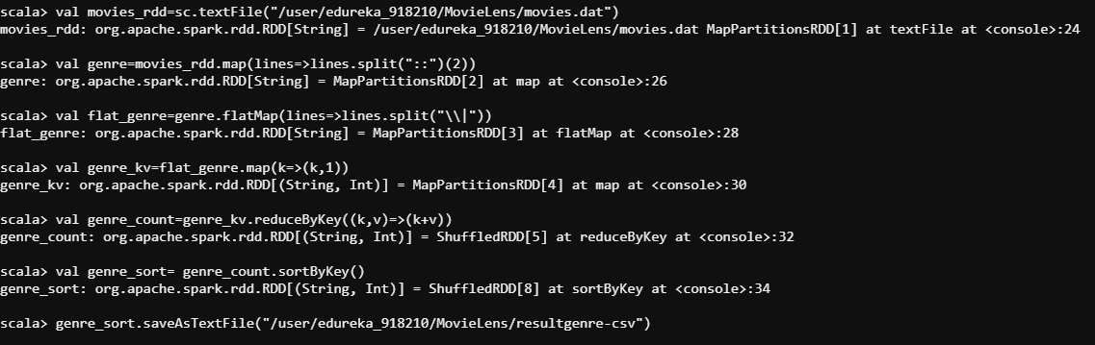

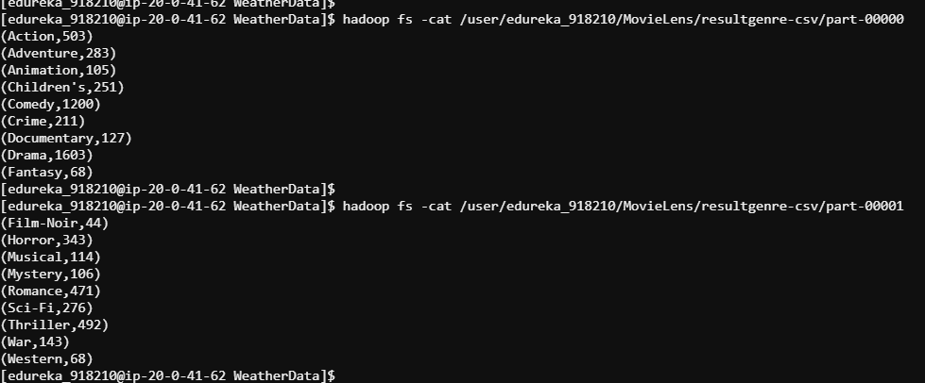

**Latest Movies**

val movies_rdd=sc.textFile("/user/edureka_918210/MovieLens/movies.dat")

val movie_nm=movies_rdd.map(lines=>lines.split("::")(1))

val year=movie_nm.map(lines=>lines.substring(lines.lastIndexOf("(")+1,lines.lastIndexOf(")")))

val latest=year.max

val latest_movies=movie_nm.filter(lines=>lines.contains("("+latest+")")).saveAsTextFile("/user/edureka_918210/MovieLens/LatestResults.csv")

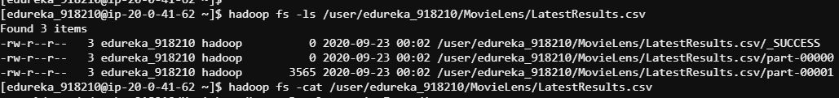

SPARK SQL DATALAKE : ALTERNATIVE MOTHOD :

[edureka_918210@ip-20-0-41-62 ~]$ hadoop fs -ls /user/edureka_918210/MovieLens

Found 4 items

drwxr-xr-x - edureka_918210 hadoop 0 2020-08-05 08:25 /user/edureka_918210/MovieLens/Top-10-CSV

-rw-r--r-- 3 edureka_918210 hadoop 175191 2020-08-05 06:55 /user/edureka_918210/MovieLens/movies.dat

-rw-r--r-- 3 edureka_918210 hadoop 25594340 2020-08-05 06:55 /user/edureka_918210/MovieLens/ratings.dat

-rw-r--r-- 3 edureka_918210 hadoop 140408 2020-08-05 06:55 /user/edureka_918210/MovieLens/users.dat

**// 2nd method is to read the file directly into a dataFrame and create a temp view**

spark.read.textFile("/user/edureka_918210/MovieLens/movies.dat").createOrReplaceTempView("movies_staging");

spark.read.textFile("/user/edureka_918210/MovieLens/ratings.dat").createOrReplaceTempView("ratings_staging");

spark.read.textFile("/user/edureka_918210/MovieLens/users.dat").createOrReplaceTempView("users_staging");

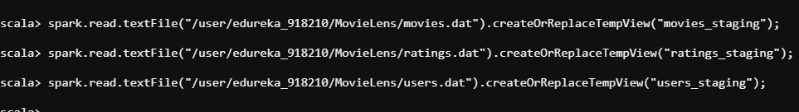

**// Create a database to store the tables**

spark.sql("drop database if exists sparkdatalake cascade")

spark.sql("create database sparkdatalake");

**// Make appropriate schemas for them**

**// movies**

spark.sql(""" Select

split(value,'::')[0] as movieid,

split(value,'::')[1] as title,

substring(split(value,'::')[1],length(split(value,'::')[1])-4,4) as year,

split(value,'::')[2] as genre

from movies_staging """).write.mode("overwrite").saveAsTable("sparkdatalake.movies");

// users

spark.sql(""" Select

split(value,'::')[0] as userid,

split(value,'::')[1] as gender,

split(value,'::')[2] as age,

split(value,'::')[3] as occupation,

split(value,'::')[4] as zipcode

from users_staging """).write.mode("overwrite").saveAsTable("sparkdatalake.users");

// ratings

spark.sql(""" Select

split(value,'::')[0] as userid,

split(value,'::')[1] as movieid,

split(value,'::')[2] as rating,

split(value,'::')[3] as timestamp

from ratings_staging """).write.mode("overwrite").saveAsTable("sparkdatalake.ratings");

System.exit(0)

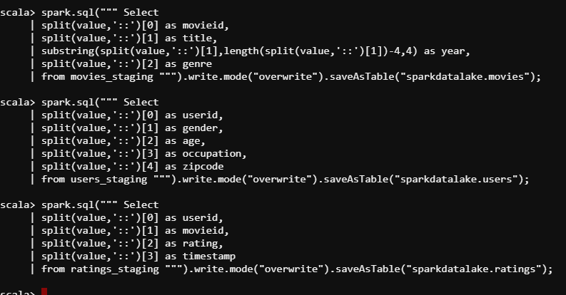

TABLES IN SPARK ARE :

//movies

spark.sql(""" Select

split(value,'::')[0] as movieid,

split(value,'::')[1] as title,

substring(split(value,'::')[1],length(split(value,'::')[1])-4,4) as year,

split(value,'::')[2] as genre

from movies_staging """).show(false)

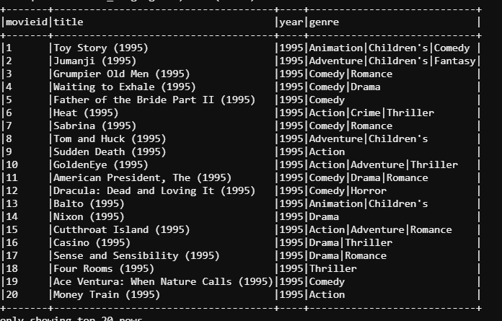

// users

spark.sql(""" Select

split(value,'::')[0] as userid,

split(value,'::')[1] as gender,

split(value,'::')[2] as age,

split(value,'::')[3] as occupation,

split(value,'::')[4] as zipcode

from users_staging """).show(false)

// ratings

==============================================================================================================================================================

spark.sql(""" Select

split(value,'::')[0] as userid,

split(value,'::')[1] as movieid,

split(value,'::')[2] as rating,

split(value,'::')[3] as timestamp

from ratings_staging """).show(false)

**//Total Ratings Per Movie**

spark.sql("""Select INT(movieid),sum(INT(rating)) as Total_ratings from sparkdatalake.ratings group by movieid order by movieid""").show(false)

spark.sql("""Select INT(movieid),sum(INT(rating)) as Total_ratings from sparkdatalake.ratings group by movieid order by movieid""").repartition(1).write.format("csv").option("header","true").save("ResultTotalRatings")

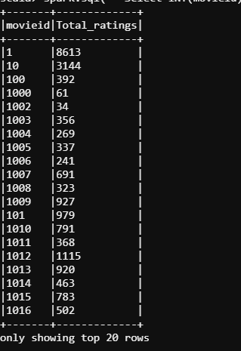

**//Number of Users per movie**

spark.sql("""Select INT(movieid),count(INT(userid)) as Total_number_of_Users from sparkdatalake.ratings group by movieid order by movieid""").show(false)

spark.sql("""Select movieid,count(userid) as Total_number_of_Users from sparkdatalake.ratings group by movieid order by movieid asc""").repartition(1).write.format("csv").option("header","true").save("ratingscount")

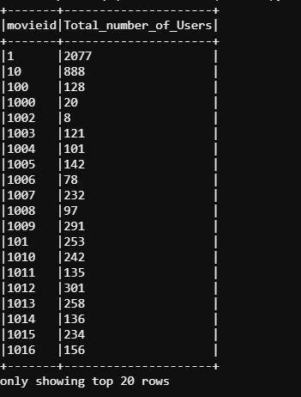

**//Average rating per movie**

spark.sql("""Select INT(movieid),avg(decimal(rating)) as Average_ratings from sparkdatalake.ratings group by movieid order by movieid asc""").show(false)

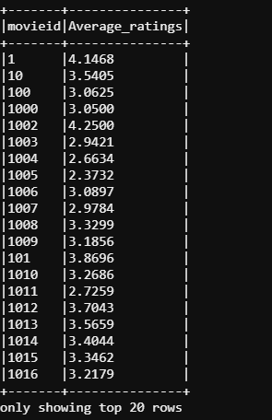

spark.sql("""Select INT(movieid),avg(decimal(rating)) as Average_ratings from sparkdatalake.ratings group by movieid order by movieid asc""").repartition(1).write.format("csv").option("header","true").save("resultavgratings")

**//LIST OF OLDEST MOVIES**

val movies_rdd=sc.textFile("/user/edureka_918210/MovieLens/movies.dat")

// 1st method, convert existing rdd into DF using toDF function and then make it into a view

val movies_DF=movies_rdd.toDF.createOrReplaceTempView("movies_view")

// To use spark.sql, it should be at least a temporary view or even an table

spark.sql(""" select

split(value,'::')[0] as movieid,

split(value,'::')[1] as moviename,

substring(split(value,'::')[1],length(split(value,'::')[1])-4,4) as year

from movies_view """).createOrReplaceTempView("movies");

// To view the records, use spark.sql("select * from movies").show()

var result=spark.sql("Select * from movies m1 where m1.year=(Select min(m2.year) from movies m2)").repartition(1).rdd.saveAsTextFile("result")

spark.sql("Select * from movies m1 where m1.year=(Select min(m2.year) from movies m2)").show(false)

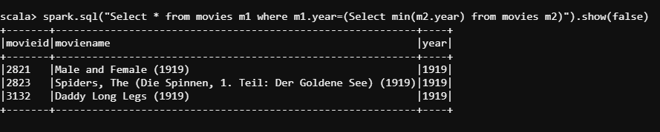

spark.sql("Select * from movies m1 where m1.year=(Select min(m2.year) from movies m2)").show(false)

